Introduction:
COVID-19 a disease caused by SARS -CoV-2 corona virus, was first recognised in December 2019. The disease was declared a pandemic by the WHO in March 2020. The reported COVID-19 cases and deaths across the world has been staggering with the highest number of cases and deaths being in the US. So, with the rise in the number of cases and mortality in some regions we wanted to know the trend of the pandemic in Canada and the world over, the economic impact it has had with respect to unemployment and GDP growth, its impact on excess deaths and the relationship between COVID 19 and deaths due to other disease such as Influenza and Pneumonia. To find answers to the above questions that we had, we scraped the web, pulled data from various data sources such as Kaggle, worldometer, ourworlddata in the CSV and json format and extracted them into pandas where we extracted, cleaned, and transformed the data before loading it into SQL.

Method:
- Extract (HTML Parsing)
We scraped a web page from worldometer for the continuation of our project on COVID 19. The website is reliable and credible from data around the world and this data on worldometer is updated frequently.
The first thing to scrape a page is to download the page. We download the page by making a GET request to the web server which will download the HTML contents of the webpage. After running the request, we get a response object which has a status code property which indicates if the HTML page has been downloaded successfully. A status code of 200 means that the page has been downloaded successfully.
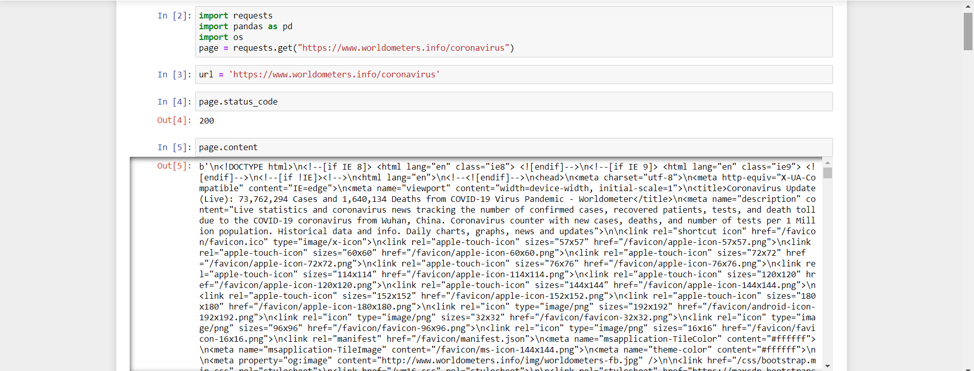

We use Beautiful Soup to parse the HTML document from which we want to extract information.
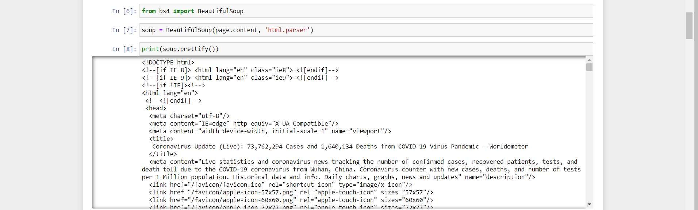
To adequately extract the data from the webpage we must inspect the webpage to find its attributes and tags. We can run inspect by clicking anywhere on the webpage and selecting ‘inspect’. With the regards to this HTML parsing exercise, we are looking for the attributes and tags related to the table on ‘reported coronavirus cases’
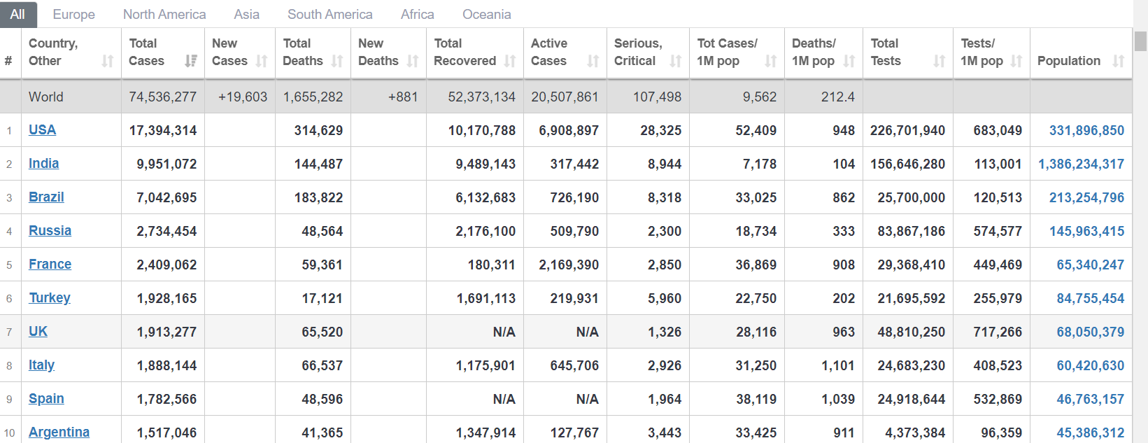
Extraction of Table
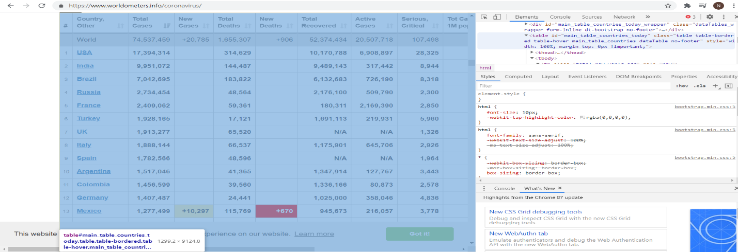
Once the inspection is successfully completed and the attributes ‘id’ is identified the attributes will be used to filter the HTML document to get the required table elements.
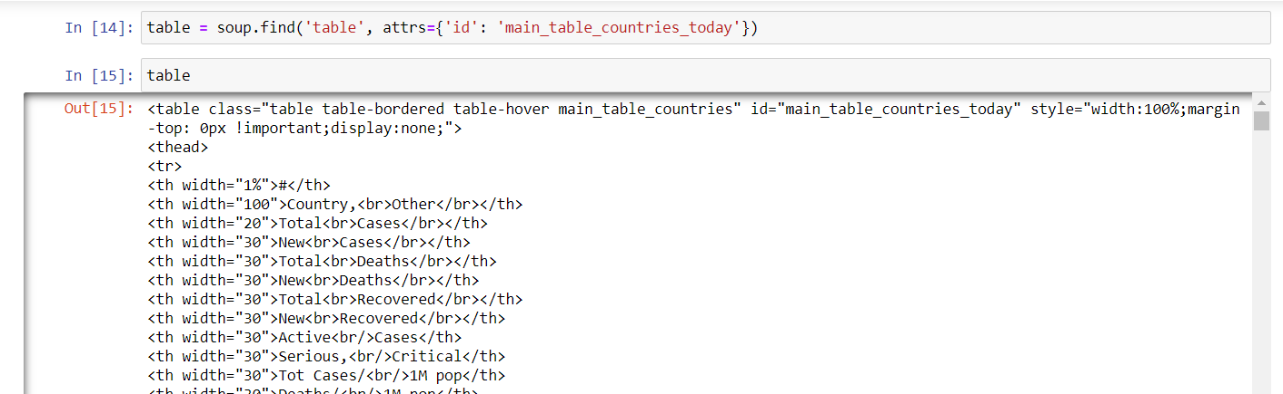

Extracting the text from the extracted the table:
The table that is extracted is basically HTML tags embedded. The goal of the exercise on parsing is to take the table from the webpage and convert it into a data frame for further use such as cleaning and transforming to be loaded into Postgres. To achieve this, we try to retrieve the text on a row-wise basis on a list form first and then convert that list into a data frame. The tags td, tr and th, represent the table column, table rows and table headers, respectively.

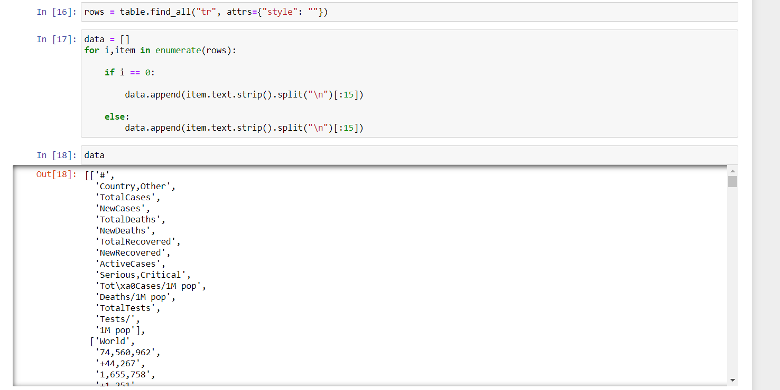

- Transform (Transforming the list into Pandas data frame)
The next step is to convert the list into a data frame. The data is extracted into a pandas data frame and from the pandas data frame the cleaning process by importing pandas into the jupyter notebook.
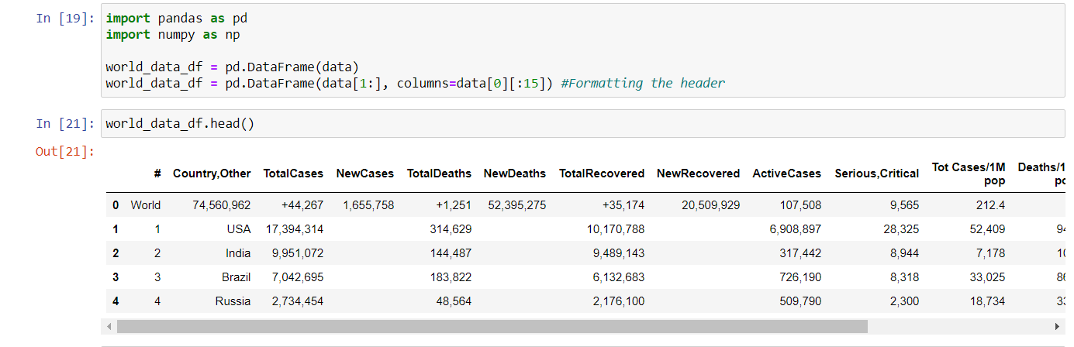

The pandas data frame is cleaned by dropping columns that are not needed.
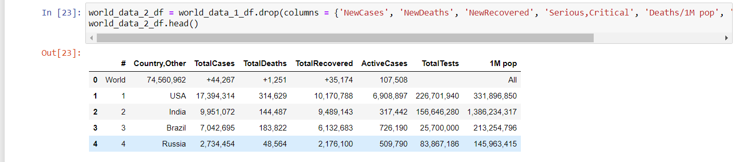

The data frame columns are then renamed.
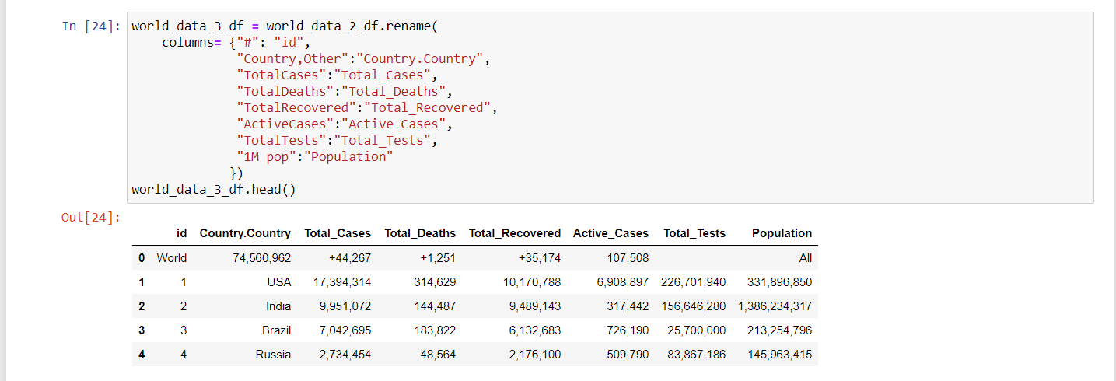

The data frame columns that have unwanted syntaxes are removed and top row which is not needed is dropped as well.
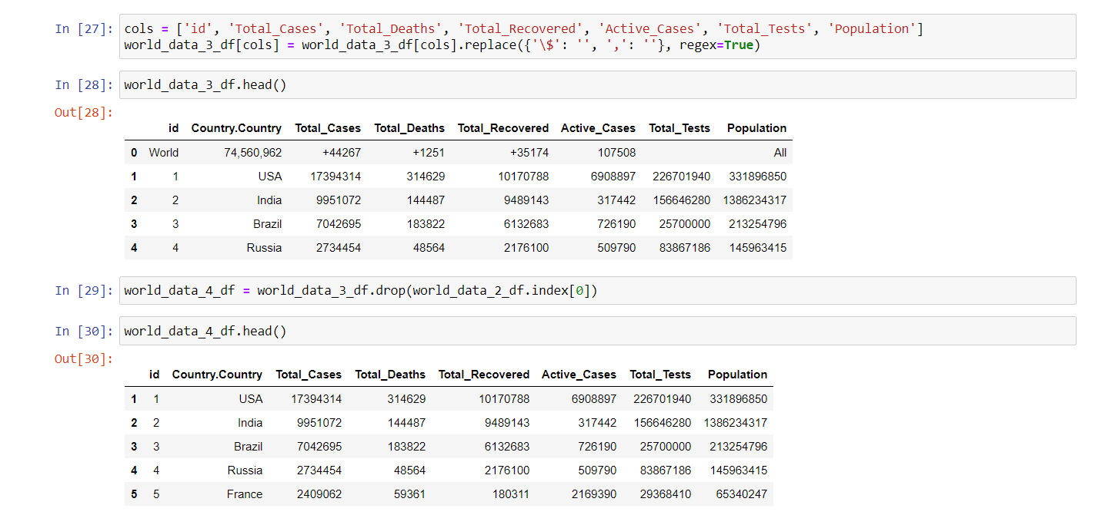

The data frame type is converted from object to integer wherever needed in the columns.
